**1: Introduction & Overview of Digital Electronics**

**Digital electronics** form the backbone of modern computing and information processing. At its heart lies binary logic, where signals exist in two distinct states—0 (low/off) and 1 (high/on). The methodology for processing these binary signals is based on Boolean algebra, founded by George Boole in the mid-19th century. An understanding of Boolean algebra is crucial since it provides a mathematical framework through which logic functions can be described and manipulated.

**Logic gates** are the elemental units of digital circuits. They perform logical operations—such as AND, OR, and NOT—which combine to construct more complex operations. In practice, digital systems’ behavior is determined by the way these gates are interconnected. Beyond computation, logic gates help in signal conditioning, decision-making circuits, and even in emerging fields like quantum computing, where analogous quantum logic operations are applied.

Here, we will study both **primary (basic) logic gates** and **secondary (derived) logic gates**. Primary gates—such as AND, OR, and NOT—are the fundamental building blocks; secondary gates like NAND, NOR, XOR, and XNOR result from combinations or modifications of basic gates. Together, they provide engineers with a universal set of tools to implement any Boolean function.

**1.1: Physical Principles & Semiconductor Foundations**

Digital logic is implemented using semiconductor devices—most notably transistors. In particular, technologies such as **CMOS (Complementary Metal-Oxide-Semiconductor)** use both NMOS and PMOS transistors to create robust, power-efficient logic gates. When a transistor works as a switch, it can either allow current to pass (logic 1) or block current (logic 0).

At the microscopic level, the operation of transistors is influenced by quantum mechanics and solid-state physics. The charge carriers (electrons and holes) in silicon have properties that can be controlled by electrical gates (voltages) to yield the desired binary output. This interplay of semiconductor physics and circuit design is what makes modern digital electronics not only possible but exceedingly reliable and scalable.

Understanding these physical principles is not just academic; it informs design choices in integrated circuit (IC) fabrication, power consumption minimization, and speed optimization. As we progress into each gate’s specifics, remember that beneath every truth table and block diagram is a world of physics ensuring that the theoretical logic is realized in hardware.

**1.2: Primary Logic Gate – AND Gate**

**Definition & Boolean Expression**

The **AND gate** outputs a high (logic 1) only when **all** its inputs are high. For two inputs, A and B, its Boolean function is expressed as:

Output = A · B

This operation is fundamental in systems where a decision requires multiple conditions to be true simultaneously.

**Block Diagram Truth Table**

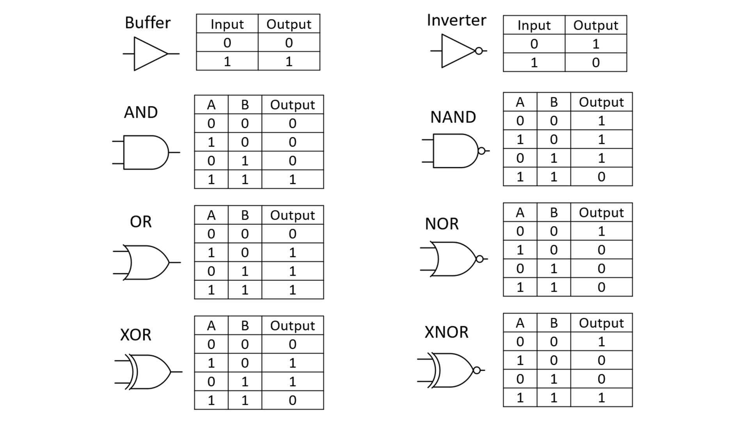

*Explanation:* In the physical realization (e.g., using CMOS technology), the AND gate can be constructed by arranging a series of transistors such that the conduction path is established only when both inputs are at the high level. This series configuration is essential to ensure that if any input is low, the switching path is broken, resulting in a low output.

**1.3: Primary Logic Gate – OR Gate**

**Definition & Boolean Expression**

The **OR gate** outputs a high (logic 1) when **any one** or more of its inputs is high. Its Boolean expression for two inputs is:

Output = A + B

This gate is pivotal in scenarios involving alternative conditions where at least one should be valid.

**Block Diagram Truth Table**

*Explanation:* In an OR gate physical implementation, the circuit may use parallel pathways, which means if either input channel is activated (high), the overall circuit will deliver a high output. The arrangement in CMOS, for instance, uses both NMOS and PMOS transistors in a complementary layout that honors this parallel logic behavior.

**1.4: Primary Logic Gate – NOT Gate**

**Definition & Boolean Expression**

The **NOT gate**, also known as an inverter, reverses the state of its input. Its Boolean expression is:

Output = 𝑓(A) = 𝑪𝒐𝒎𝒑𝒍𝒆𝒎𝒆𝒏𝒕(A) = **Ā**

**Block Diagram Truth table**



*Explanation:* The NOT gate is the simplest of all logic gates. Inverters are used to provide signal complement and are essential in creating complex Boolean functions. Physically, a transistor arranged in a simple inverter configuration uses its threshold voltage to decide whether to allow conduction or not, thereby flipping the signal polarity.

**1.5: Secondary Logic Gate – NAND Gate**

**Definition & Boolean Expression**

The **NAND gate** is a combination of an AND gate followed by a NOT gate. Its Boolean expression for two inputs is:

Output = (A · B)

This gate outputs a low (0) only when **all** inputs are high and is high for all other combinations.

**Block Diagram Truth Table**



*Explanation:* In CMOS technology, the NAND gate is favored due to its high noise margins and low power consumption. The universality of the NAND gate is of special importance—it is possible to build any Boolean function using only NAND gates. This universality simplifies manufacturing and design considerations in digital integrated circuits.

**1.6: Secondary Logic Gate – NOR Gate**

**Definition & Boolean Expression**

The **NOR gate** is derived from the OR gate with an inversion applied to its output. For two inputs, its Boolean expression is:

Output = (A + B)

It outputs a high (1) only when **all** inputs are low.

**Block Diagram Truth Table**

*Explanation:* The NOR gate, like the NAND gate, is universal. This means that by adequately combining NOR gates, any Boolean function can be synthesized. In practical circuitry, using NOR structures can provide simplified layouts and may offer benefits in reducing the number of components required in certain IC designs.

**1.7: Secondary Logic Gate – XOR Gate (Exclusive OR)**

**Definition & Boolean Expression**

The **XOR (Exclusive OR) gate** produces a high (1) output when the number of high inputs is odd. For the common two-input configuration, the XOR operation is defined as:

Output = (A · B) + (A · B)

It effectively distinguishes between equal and unequal inputs.

**Block Diagram Truth Table**



*Explanation:* An XOR gate is fundamental in digital arithmetic circuits, error detection, and correction circuits. Its ability to detect differences between bits makes it a crucial component in parity generators and checkers. The physical implementation often involves several transistors arranged in a combination of basic gates (AND, OR, and NOT) or as a dedicated structure in high-speed logic circuits.

**1.8: Secondary Logic Gate – XNOR Gate (Exclusive NOR)**

**Definition & Boolean Expression**

The **XNOR gate** (or equivalence gate) is the complement of the XOR gate. It outputs a high (1) when the inputs are identical—both high or both low. Its Boolean function may be written as:

Output = (A XOR B) = (A · B) + (A · B)

**Block Diagram Truth Table**

*Explanation:* The XNOR gate is used in circuits where equality detection is required, such as comparators in digital systems. Physically, designing an XNOR often involves combining an XOR gate with an inverter. This layered approach, which is common in digital IC design, emphasizes balance between complexity and performance.

**1.9: Summary, Applications & Further Insights**

**Summary:** Over the previous pages, we have dissected the fundamental logic gates employed in digital electronics. Starting from primary gates like AND, OR, and NOT, we delved into their operation, physical realization, and truth tables. Secondary gates—NAND, NOR, XOR, and XNOR—were introduced as derived functions that not only offer versatility in logic design but also possess the intriguing property of universality (in the case of NAND and NOR).

**Applications & Design Considerations:**

* **Integrated Circuit Design:** Modern ICs, from microprocessors to FPGAs, use millions (or billions) of these basic logic elements. The choice between different gate types can affect speed, power consumption, and ease of fabrication.
* **Combinational vs. Sequential Circuits:** While these notes have focused on combinational logic (where outputs depend solely on current inputs), similar principles extend to sequential circuits that incorporate memory (flip-flops, registers, etc.).
* **Circuit Optimization:** Techniques such as Karnaugh maps or Boolean algebra simplification are used to minimize the number of gates or transistor count, optimizing chip area and power efficiency.
* **Advanced Topics:** In quantum computing, analogs of these logic gates (such as quantum controlled-NOT, Hadamard, etc.) play a role in evolving computational paradigms. Researchers draw parallels between classical gate logic and quantum logic to solve complex computational problems.

**Further Exploration:**

* **Physical Implementation:** Study CMOS technology in greater depth by examining how NMOS and PMOS transistors are arranged together. Explore factors such as threshold voltage, switching speed, and energy dissipation.
* **Error Correction and Parity:** Understand how XOR and XNOR functions are pivotal in error-detection and correction algorithms used in communication systems.
* **Logic Synthesis:** Investigate how higher-level Boolean functions are synthesized from these elementary gates using hardware description languages (HDLs) like VHDL or Verilog.
* **Emerging Technologies:** Consider the role of logic gate design in the emerging fields of nanotechnology and spintronics, where conventional transistor operation is reimagined at the quantum scale.